UNITED STATES

SECURITIES AND EXCHANGE COMMISSION

Washington, D.C. 20549

SCHEDULE 14A

Proxy Statement Pursuant to Section 14(a) of the Securities

Exchange Act of 1934 (Amendment No. )

☒ Filed by the Registrant | Filed by a Party other than the
☒ Filed by the Registrant | ☐Registrant
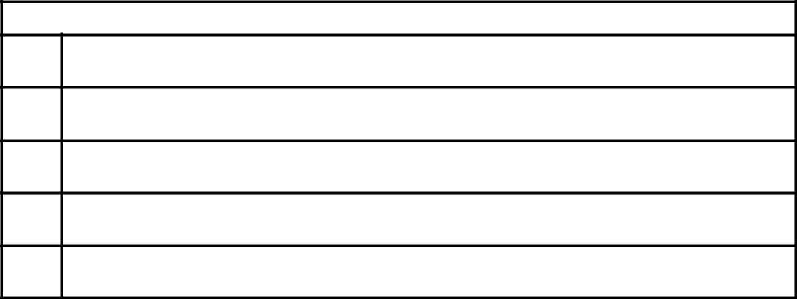
Check the appropriate box:

- Preliminary Proxy Statement

- CONFIDENTIAL, FOR USE OF THE COMMISSION ONLY (AS PERMITTED BY RULE 14a-6(e)(2))

- Definitive Proxy Statement

- Definitive Additional Materials

- Soliciting Material Under Rule 14a-12

Progress Software Corporation

(Name of Registrant as Specified In Its Charter)

(Name of Person(s) Filing Proxy Statement, if Other than the Registrant)
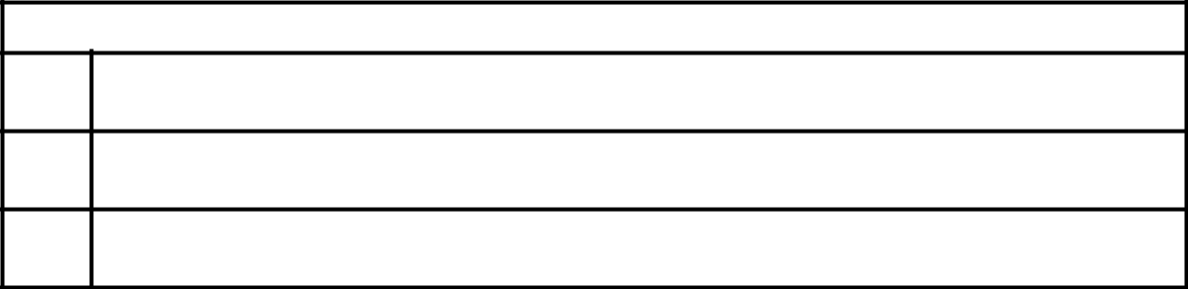

Payment of Filing Fee (Check the appropriate box):

- No fee required.

- Fee paid previously with preliminary materials.

- Fee computed on table in exhibit required by Item 25(b) per Exchange Act Rules 14a-6(i)(1) and 0-11.



